**LABVIEW**

**CLAD Project: ATM**

**by**

**160040595 – N. BHARGAVA SAI**

This VI is an ATM with Operation such as Withdraw, Deposit, Balance Enquiry and Transfer Money (from one account to an another).

**Login:**

**Front Panel:**

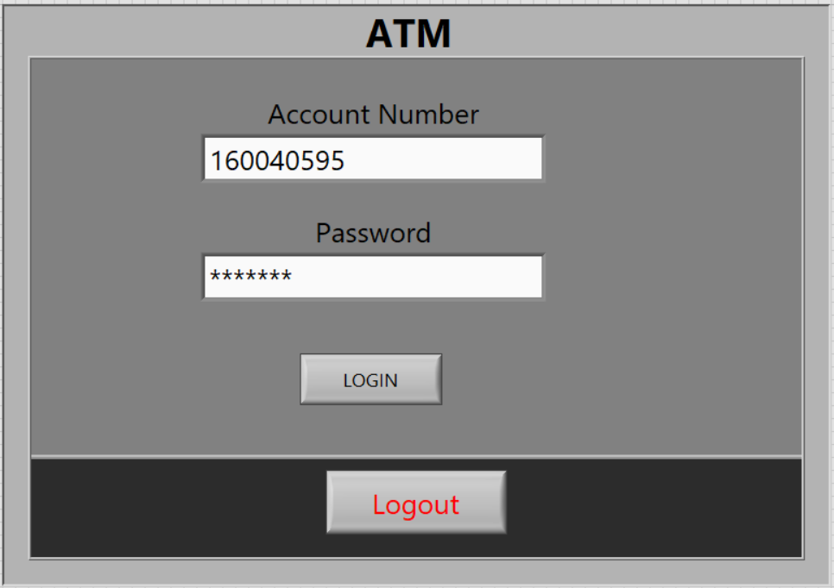

**Block Diagram:**

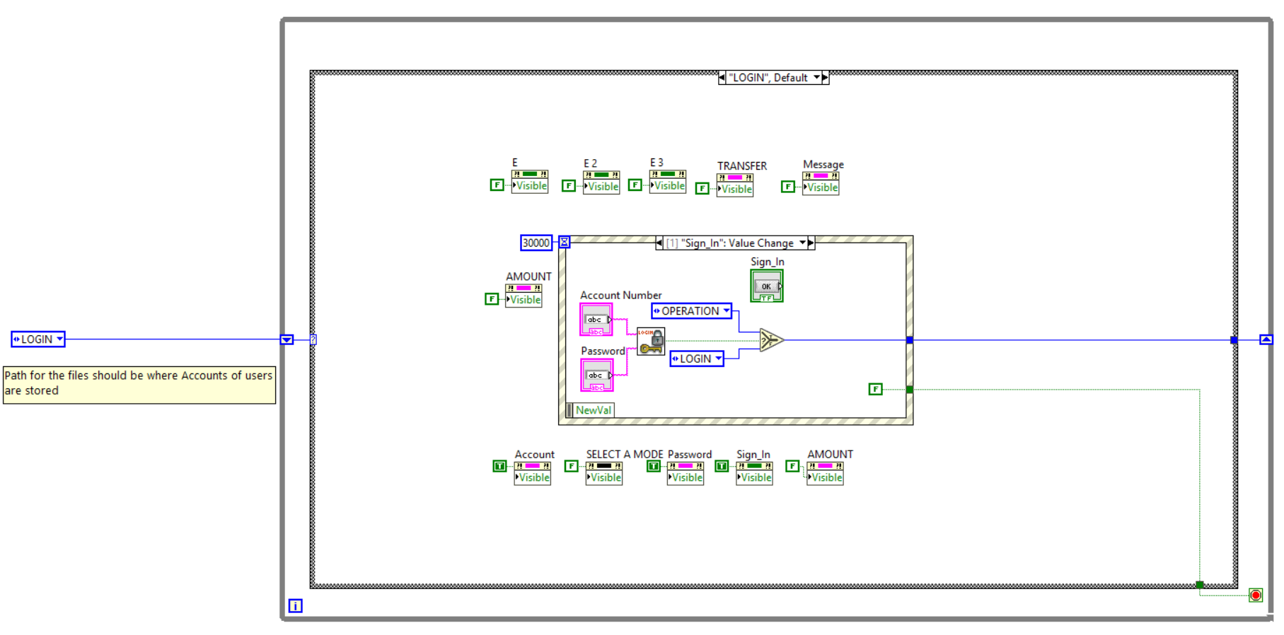

**Operations:**

**Front Panel**

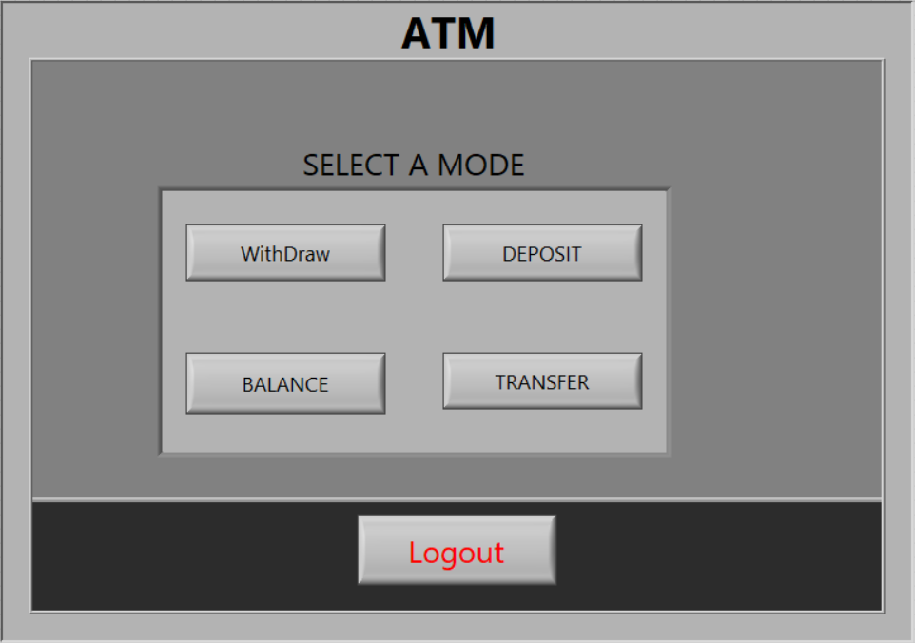

**Block Diagram**

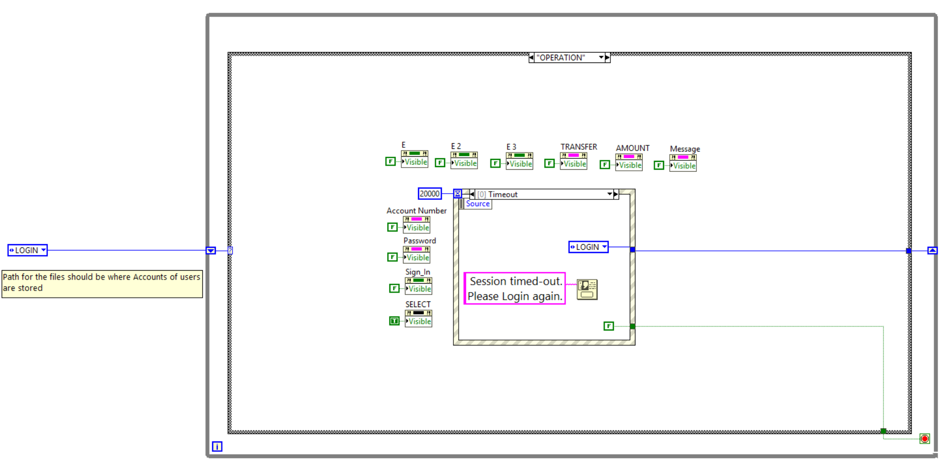

**Operation1: Withdraw**

**Front Panel**

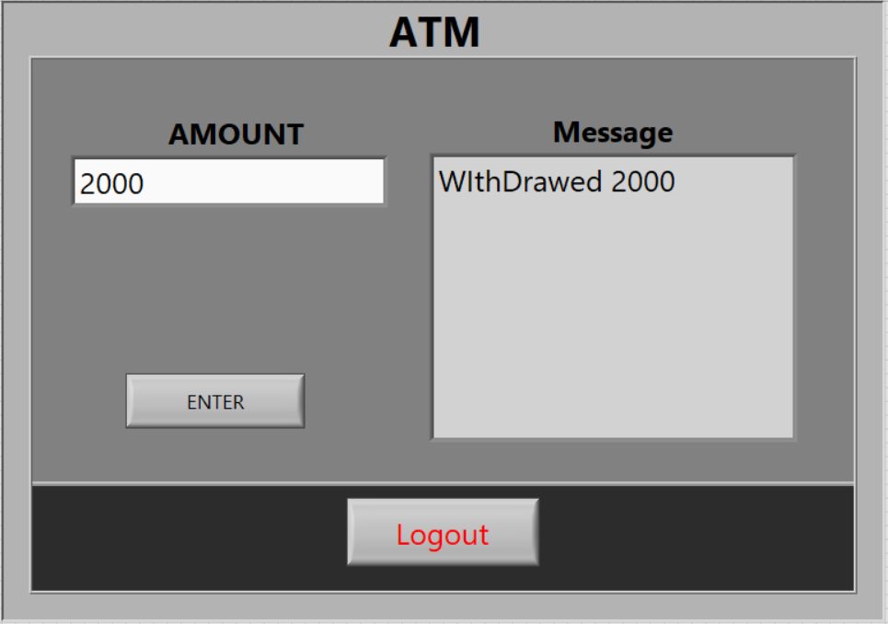

**Block Diagram**

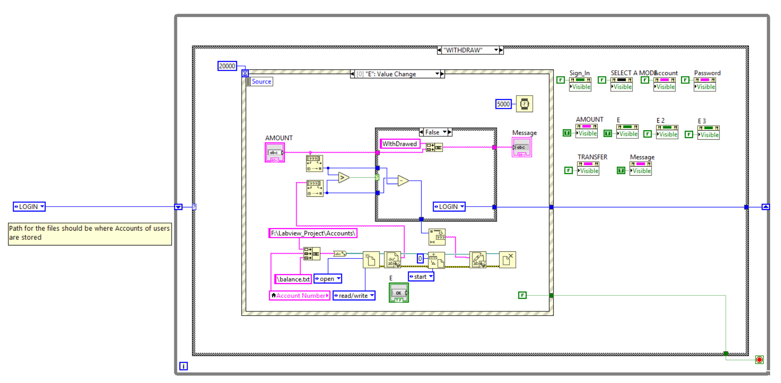

**Operation2: Deposit**

**Front Panel**

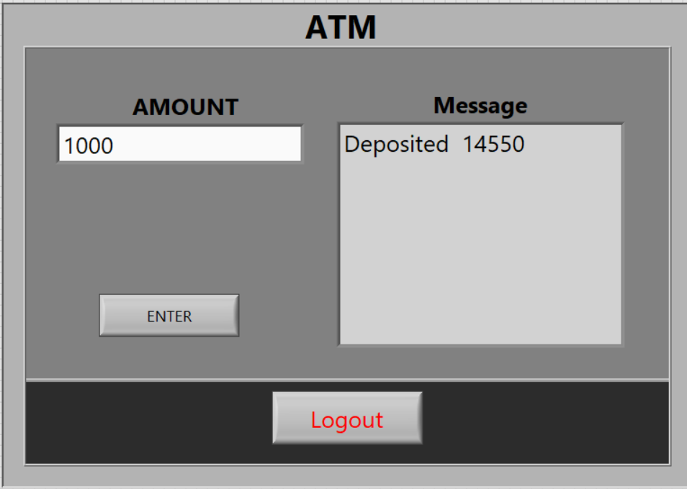

**Block Diagram**

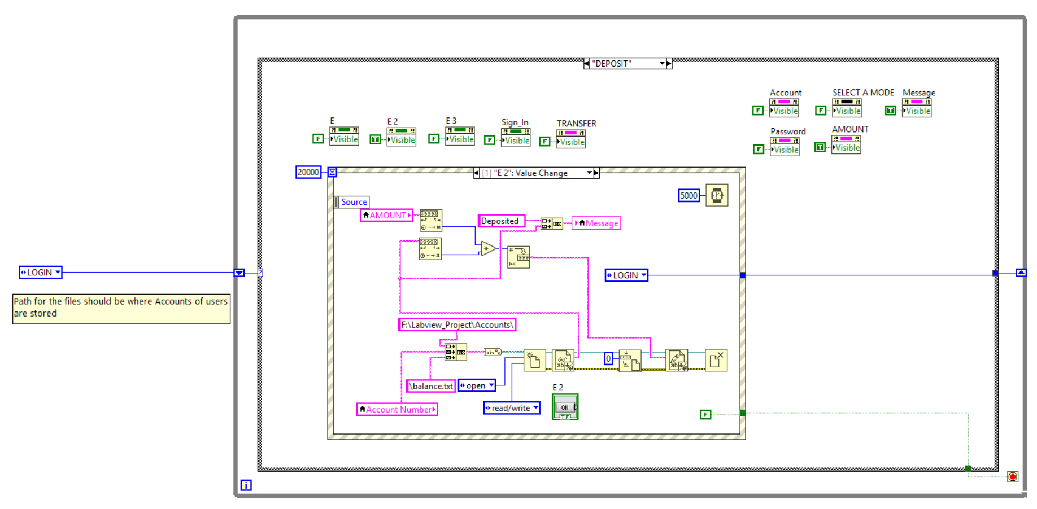

**Operation3: Balance Enquiry**

**Front Panel**

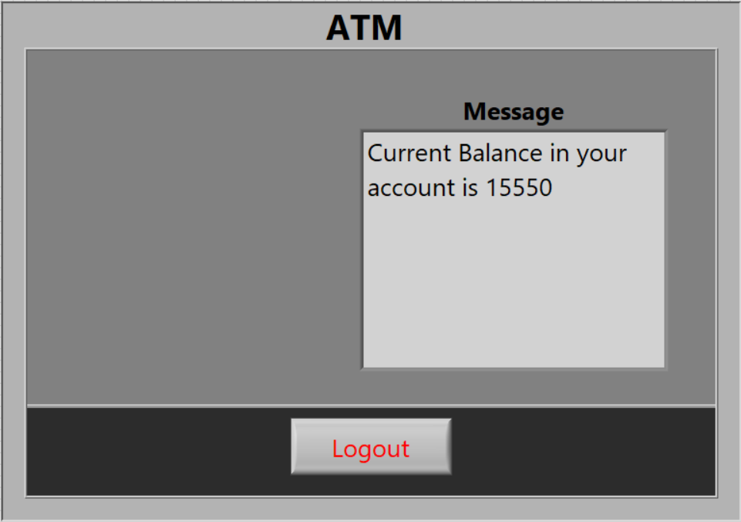

**Block Diagram**

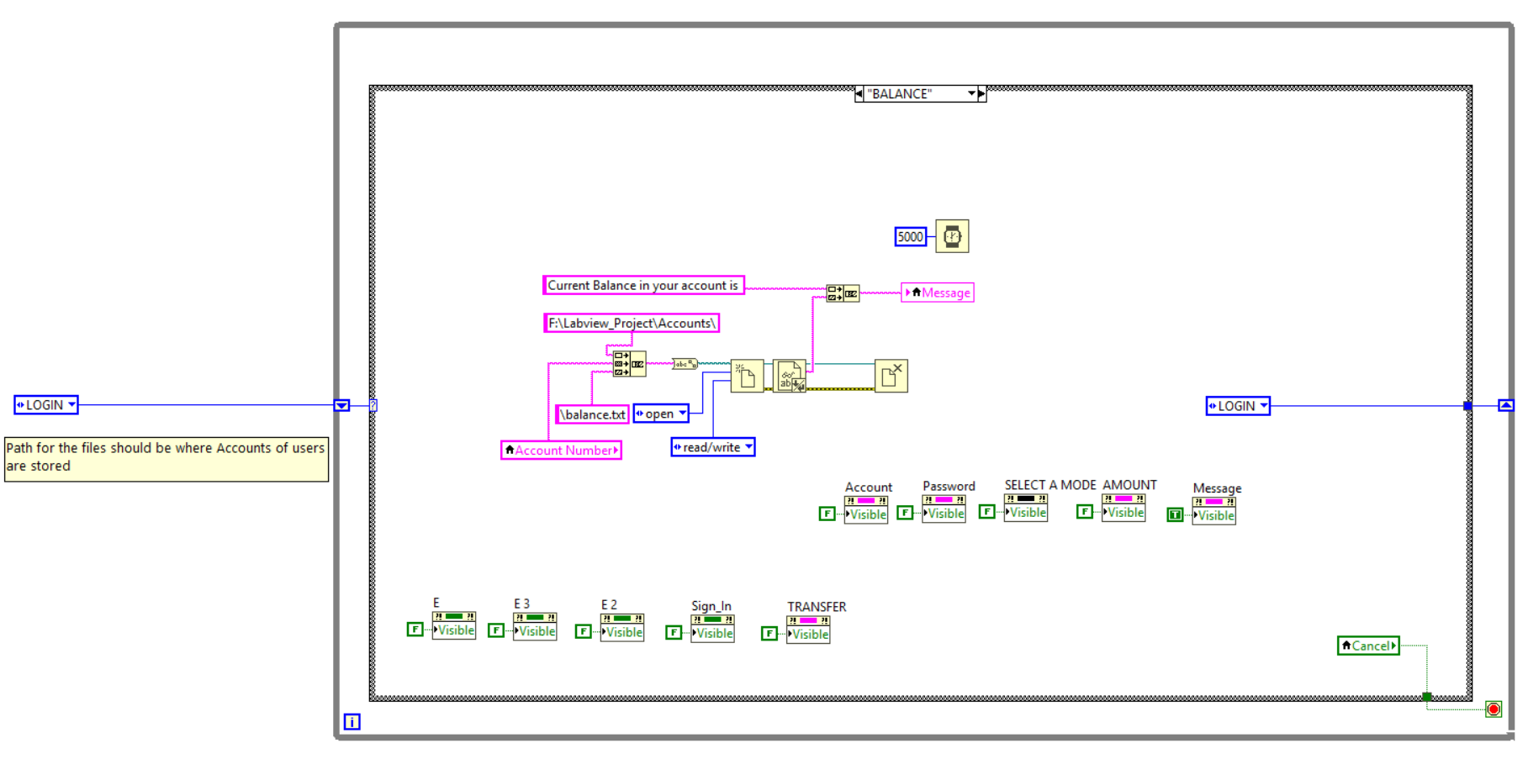

**Operation4: Transfer**

**Front Panel**

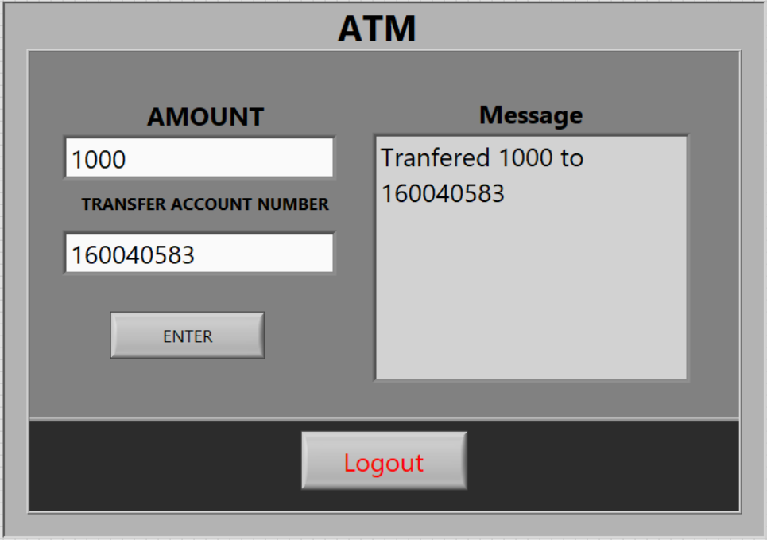

**Block Diagram**

